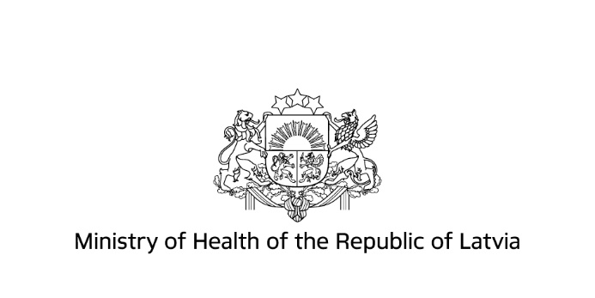
Information for Ukrainian citizens about health care services in Latvia

All the state funded healthcare services are available to you for free
For information, questions 📞 80001234
(Monday-Thursday 8:30–17:00, Friday – 8:30–15:00, in English and Russian).
📞 from foreign phone numbers: +371 67045005
Ministry of Health 🌐 www.vm.gov.lv
National Health Service 🌐 www.vmnvd.gov.lv

IN LIFE-SAVING SITUATION – 📞 emergency medical aid 113 or 112

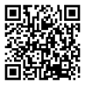
MEDICAL AID
General practitioner – consultations, prescriptions, referral to a physician–specialist,
for examinations or analyses, vaccines etc. ✉ nvd@vmnvd.gov.lv, 📞 80001234.

Doctor on duty – medical consultations, prescriptions, etc., beyond the general practitioner's
business hours. Available in Riga and other larger cities. 🌐https://www.vmnvd.gov.lv/lv/ Kur saņemt medicīnisko palīdzību or 📞80001234.

Specialist of direct access – physician without a referral from the general practitioner: gynaecologist; oculist; paediatrist; children's surgeon; narcologist; dermatovenerologist (in case of sexually transmissive diseases); endocrinologist (in case of diabetes); oncologist, oncologist-chemical therapist (in case of oncologic disease); pneumologist (in case of tuberculosis); psychiatrist or children's psychiatrist (in case of mental illness); infectologist (in case of HIV or close contact with a HIV-infected person. 🌐https://www.vm.gov.lv Informācija Ukrainas pilsoņiem

Urgent medical aid point and hospital admission unit – urgent medical aid – sudden illness, exacerbation of chronic disease or injury. 🌐https://www.vmnvd.gov.lv/lv/Kur saņemt medicīnisko palīdzību or 📞80001234.

General practitioner’s hotline 📞66016001 – phone consultations in case of a simple illness (minor injuries, scars, cold, fever, vomiting, bruises etc.). Business days 17:00–8:00, weekends, public holidays – 24 h, also in Russian.

Dentistry – state funded for children up to the age of 18, paid service for adults. For information 📞 80001234.

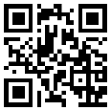
PSYCHOEMOTIONAL SUPPORT – free support services for adults and children
🌐https://www.vm.gov.lv Informācija Ukrainas pilsoņiem.
.

COVID-19 (www.covid19.gov.lv/en) – Testing – in case of Covid-19 symptoms, state pays for laboratory test. No referral is required. 📞 8303 (business days 8:00–18:00, weekends 9:00–14:00).Vaccination – at the general practitioner or 📞 8989 (business days 8:00–20:00; weekends 9:00–18:00). Communication in Latvian, English or Russian. Certificate – not required upon entry in Latvia, for receipt of services and in other cases, passport of a citizen of Ukraine is required. Information – 8989 (business days 8:00–20:00, weekends 9:00– 18:00). About Covid-19 isolation and quarantine 📞 +371 67387661 (business days 9:00–16:00).

REQUIRED DOCUMENTS – prior to receipt of service – passport/visa or permanent residence permit. If no documents are held 📞 80001234. No patient's co-payment (not applicable to paid services – find out in advance).

